Computational protocols for molecular structure and spectroscopy
Malgorzata Biczysko
Shanghai University, China
malgo.biczysko@gmail.com, biczysko@shu.edu.cn

Molecular systems of increasing size and complexity from small prebiotic molecules of astrochemical interest to larger bio-molecules such as proteins are nowadays studied by broad range of experimental techniques, involving different parts of electromagnetic spectrum, as depicted in Figure 1. However, it is seldom straightforward to link the rich experimental data to the desired information on the specific structure and properties of complex molecular systems.
I will discuss status and perspective of the project aimed at development, validation and application of QM based computational protocols supporting to decode and analyze experimental data based on light-matter interaction.
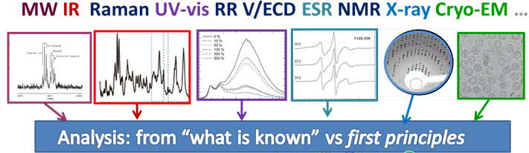
Figure 1. QM support for experiment.
[1] Y. Wang, H. Kruse, N.W. Moriarty, M.P. Waller, P.V. Afonine, M. Biczysko “Optimal clustering for quantum refinement of biomolecular structures: Q|R #4” bioRxiv (2022) DOI:10.1101/2022.11.24.517825.
[2] P. Wang, C. Shu, H. Ye, M. Biczysko “Structural and Energetic Properties of Amino-acids and Peptides Benchmarked by Accurate Theoretical and Experimental Data” J. Phys. Chem. A 125 (2021), pp. 9826-9837. DOI: 10.1021/acs.jpca.1c06504

