Practical Introduction to Artificial Intelligence in
Quantum Chemistry
Pavlo O. Dral
State Key Laboratory of Physical Chemistry of Solid Surfaces, College of Chemistry and Chemical Engineering, Fujian Provincial Key Laboratory of Theoretical and Computational Chemistry, and Innovation Laboratory for Sciences and Technologies of Energy Materials of Fujian Province (IKKEM), Xiamen University, Xiamen, Fujian 361005, China
dral@xmu.edu.cn

In this pedagogical lecture, I will give an introduction to the use of artificial intelligence/machine learning for improving the performance and accuracy of quantum chemical simulations. This introduction is practical and based on our extensive experience in research and teaching (see, e.g., the recent book Quantum Chemistry in the Age of Machine Learning, edited by P. O. Dral, Elsevier, 2023, and our group’s website dr-dral.com). I will also give concrete examples of how to perform simulations with our general-purpose package for atomistic machine learning simulations MLatom (MLatom.com) using the XACS cloud computing service (XACScloud.com).
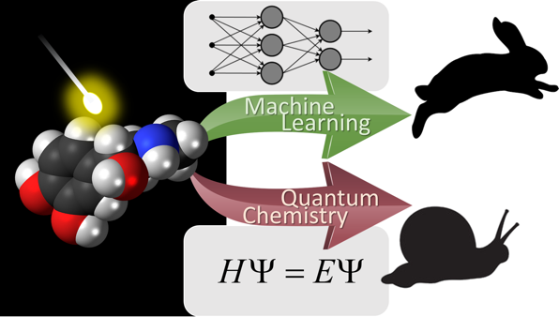
Figure 1. Machine learning greatly speeds up quantum chemical simulations, a figure from P. O. Dral, M. Barbatti. Nat. Rev. Chem. 2021, 5, 388–405.

